

The London Hogwatch Project: Queen’s Wood

Objectives
Hedgehogs are thought to have declined by about 30% over the last ten years, particularly in urban areas. Current knowledge of hedgehog populations is predominantly based on citizen reports of hedgehog sightings, which, while useful, can provide inconsistent coverage. ZSL has therefore set up the London Hogwatch project to survey London greenspaces in a systematic manner, with the aim of improving our knowledge of hedgehog locations and population sizes. The information gained will then allow us and other organisations to conserve remaining hedgehog populations in London more effectively.
Queen’s wood was identified as possibly harbouring a hedgehog population, as sightings had been recorded in the area some years ago. The objective of the survey was to see if these hedgehogs were still present in Queen’s wood and if so, get an indication of the population size. This data could then be used to investigate hedgehog habitat preferences and inform conservation actions within the wood and surrounding area.
Although the main focus of the survey is hedgehogs, it also gathered information on other wildlife using the woods, such as urban foxes.

Method
Reconyx camera traps (Figure 1) were used to survey the area, taking a sequence of ten photos in quick succession when triggered by an animal. The survey took place from the 7th June to the 20th July 2017, making a total of 560 trap nights across 15 cameras. They were placed at 34 locations in a regular pattern throughout the wood, ensuring that the survey covered the whole area. Cameras were calibrated during set up, meaning that if a population of hedgehogs was present in Queen’s wood, a statistical technique known as random encounter modelling could provide an estimate of the population size. Once the photos were collected, only those taken between 6pm and 8am were processed, avoiding the majority of human activity, while catching the vast majority of hedgehog and fox activity, given their largely nocturnal activity patterns.

Figure 1: Camera trap set up. Reconyx camera is placed inside a metal casing and locked to a tree. The pole shown here is used to calibrate the photos for REM analysis.

Results
Unfortunately, no hedgehogs were detected by the cameras at any of the locations in Queen’s wood. Foxes were abundant, with 592 records over the course of the survey and present at 33 of the 34 locations. The map below (Figure 2) indicates fox trapping rates (the number of sightings divided by the number of active nights) at each of the locations, with the larger circles representing higher trap rates.
Figure 2: Map showing Fox trapping rates at each camera location in Queen's and Highgate woods. Red indicates presence and white absence. Larger circles correspond to higher trapping rates.

Context
The results from Queen’s wood are in keeping with those found in most other London greenspaces surveyed so far (summarised in Table 1). One hedgehog was recorded in Highgate wood, however, there is unlikely to be a permanent population, as more hedgehogs would have been recorded if this was the case.
Alexandra park faired a little better, with 63 hedgehog sequences recorded. However, the hedgehogs were detected at only 8 of the 85 locations and appeared to be restricted to a small section of the park. This section was next to an allotment, and cameras then placed at this site detected a relatively high number of hedgehogs, which suggests it could be a source habitat for the area.

Table 1: Summary of survey results at three London parks in 2017. Overall trapping rate is the number of contact events captured in each park divided by the number of camera trap nights run in that park. Camera sites refers to the number of sites where hedgehogs/foxes were detected, with total number placed in brackets.
Park | Hedgehog |  |  | Fox
Park | Unique  Photographs | Camera Sites | Overall Trapping Rate | Unique Photographs | Camera Sites | Overall Trapping Rate
Alexandra Park | 63 | 8 (85) | 0.0616 | 1196 | 71 (85) | 1.17
Highgate Wood | 1 | 1 (44) | 0.00158 | 239 | 33 (44) | 0.379
Queen’s Wood | 0 | 0 (34) | 0 | 592 | 33 (34) | 1.06

A small-scale survey was also conducted on the parkland walk, which links Highgate/Queen’s wood to an area close to Alexandra Park. No hedgehogs were recorded, although they have been seen in the area.
The other North London survey location was Golders Hill. Analysis is still ongoing, but it looks promising, as a high number of hedgehog sequences have been found so far. If future surveys across the nearby Hampstead Heath find a similar result, this area of London could be a significant refuge for urban hedgehogs.

Recommendations and Future Plans
Improving the connectivity between these greenspaces could help to build and conserve hedgehog populations in North London, facilitating their dispersal into areas where they are now absent and increasing the total habitat available. This is important even in areas that have not yet lost their hedgehogs, as studies suggest that a minimum viable urban hedgehog population requires 90ha of habitat ¹. At Queen’s Wood, we noticed that a high, impermeable fence surrounded many parts of the wood. The cameras showed that foxes were still able to climb the fence (which can be seen here: www.youtube.com/watch?v=JccQkgPX9Pw), but it would be impassable for hedgehogs. One way of increasing connectivity could involve working with homeowners to make these and other fences more hedgehog friendly (e.g. inserting 13cm x 13cm holes), as gardens can be a good resource if they are able to access them, and more widely connected populations are likely to be more viable over the long term. A useful website for advice on creating these holes is available here: www.hedgehogstreet.org/help-hedgehogs/link-your-garden/.
If holes are created in the fence, it would be an interesting project for Queen’s Wood to place their own cameras by them, to keep track of their impact. There have been several recent sightings of hedgehogs by people living adjacent to the wood, so there is a reasonable chance of collecting important information about hedgehog movement and use of the holes. If Queen’s Wood is interested in this, we recommend the use of Browning camera traps, as trials suggest that they are of good quality, but significantly less expensive than the Reconyx used in this study. More information on these cameras can be found here: https://perdixwildlifesupplies.com/product/browning-strike-force-hd-pro/
The future plans for the hedgehog project are to continue with the surveys in other London greenspaces in North London, as well as expanding the surveys to new areas. As surveys have indicated that allotments could be hotspots for hedgehogs, we suggest that the neighbouring allotment to Queen’s wood, Shepherds Hill, is surveyed during 2018. If hedgehogs are present, this could provide a starting point for restoring hedgehogs to the wood.

¹ Johnson H (2014) Conservation Strategy for West-European Hedgehog (Erinaceus europaeus) in the United Kingdom (2015-2025). People’s Trust for Endangered Species, London, UK.

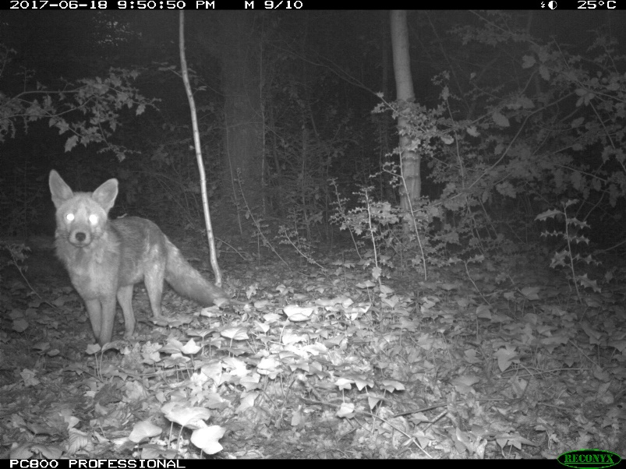
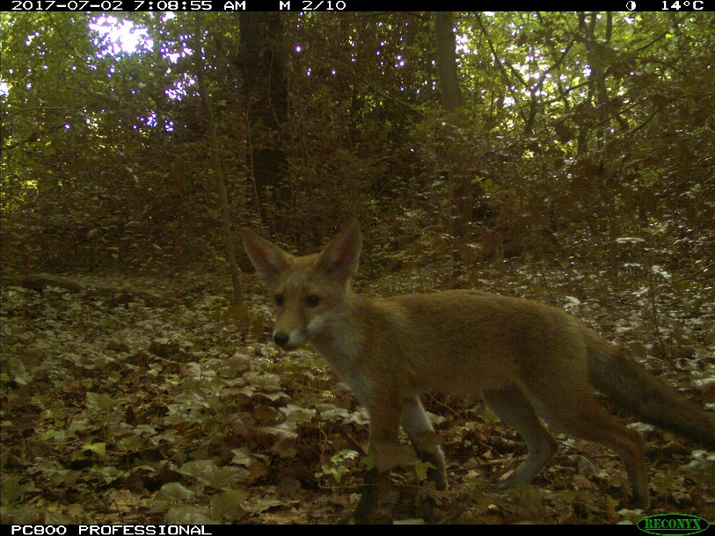
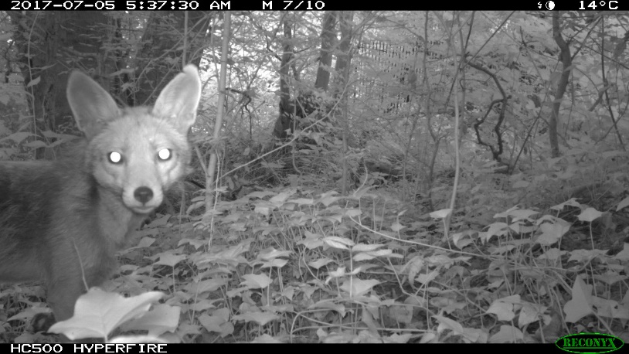
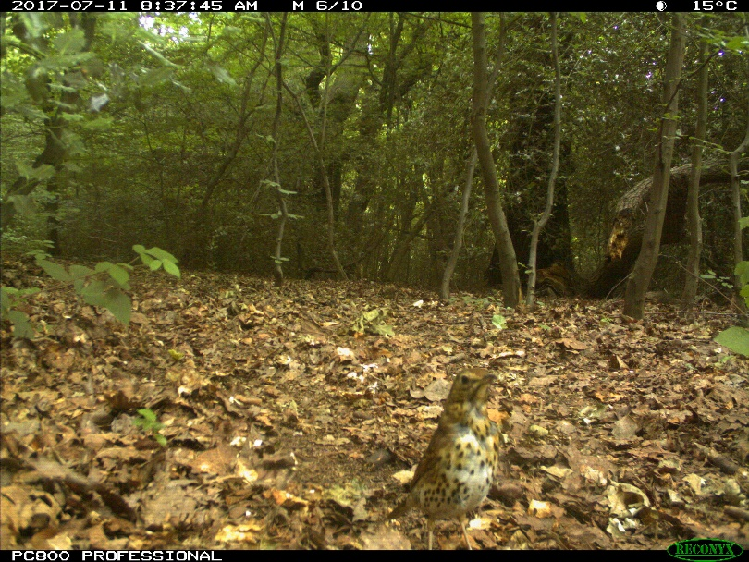
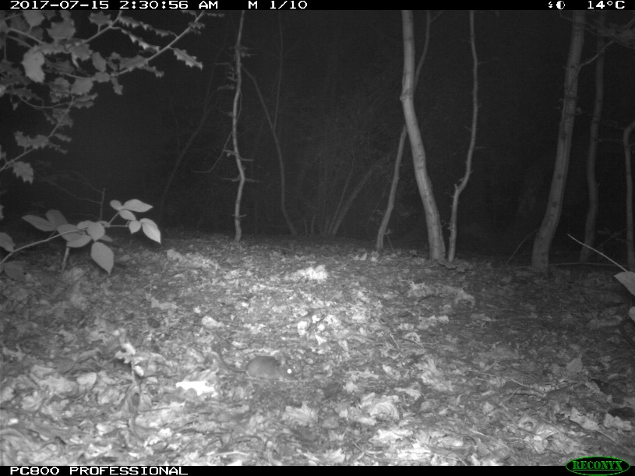
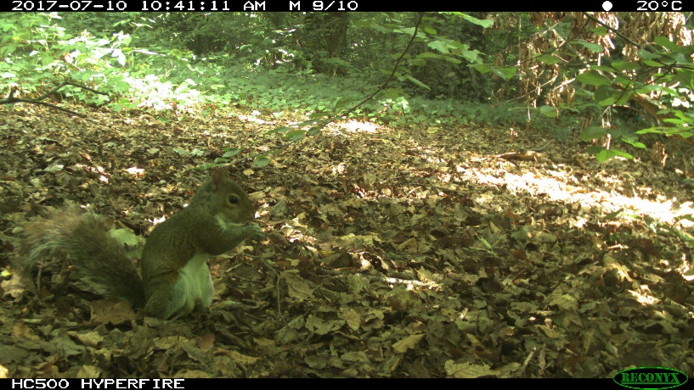
Figure 3: Example photos from the Queen’s Wood survey, showing foxes, a squirrel, a thrush and a mouse.

